Mantid
PM report to Project Management Board
13th September 2018
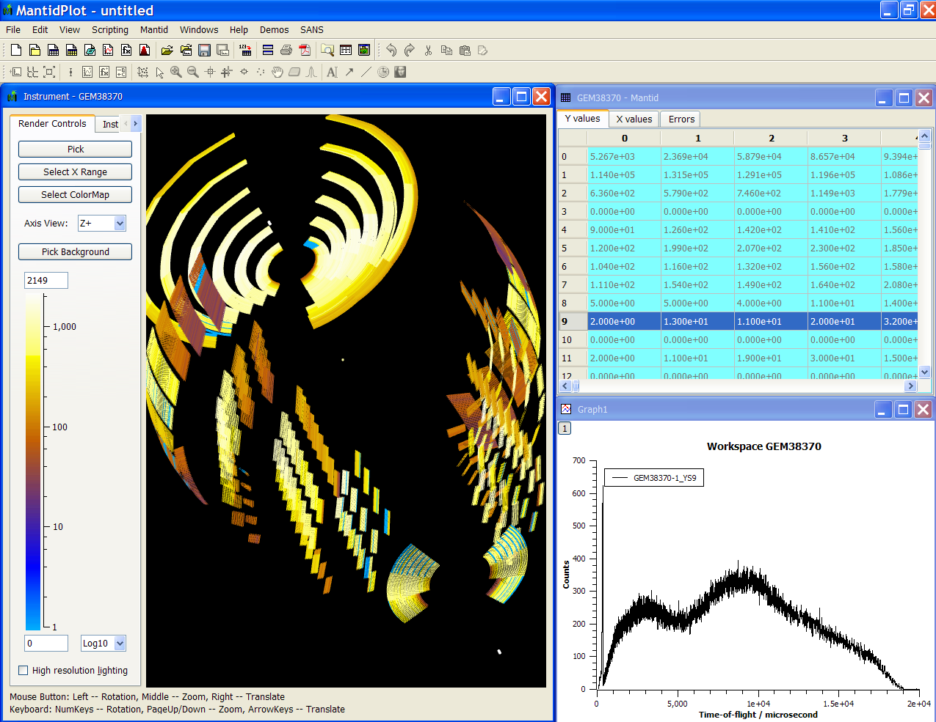
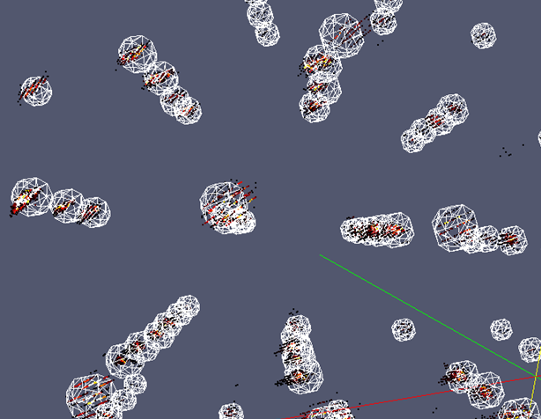
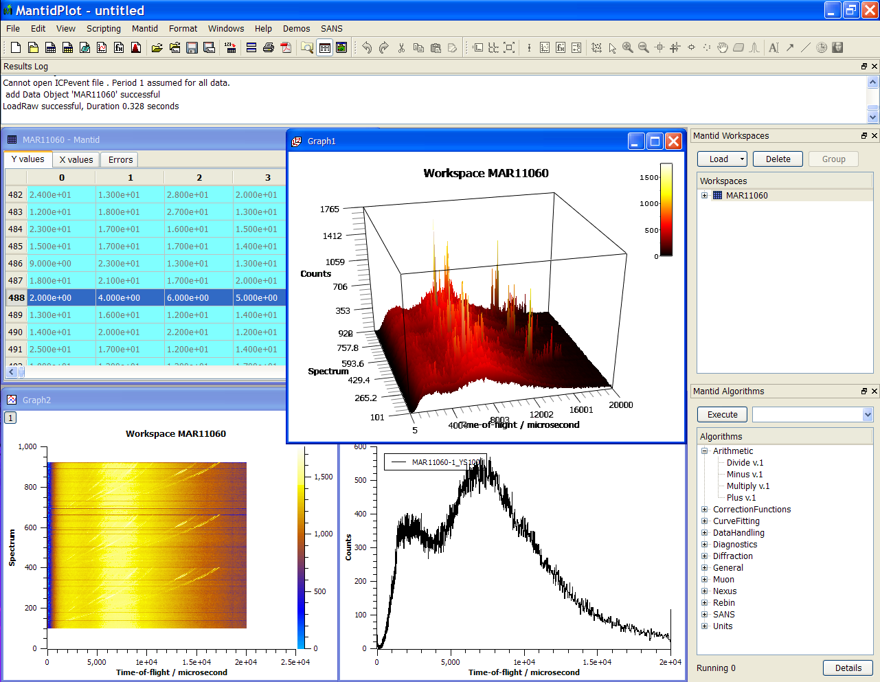
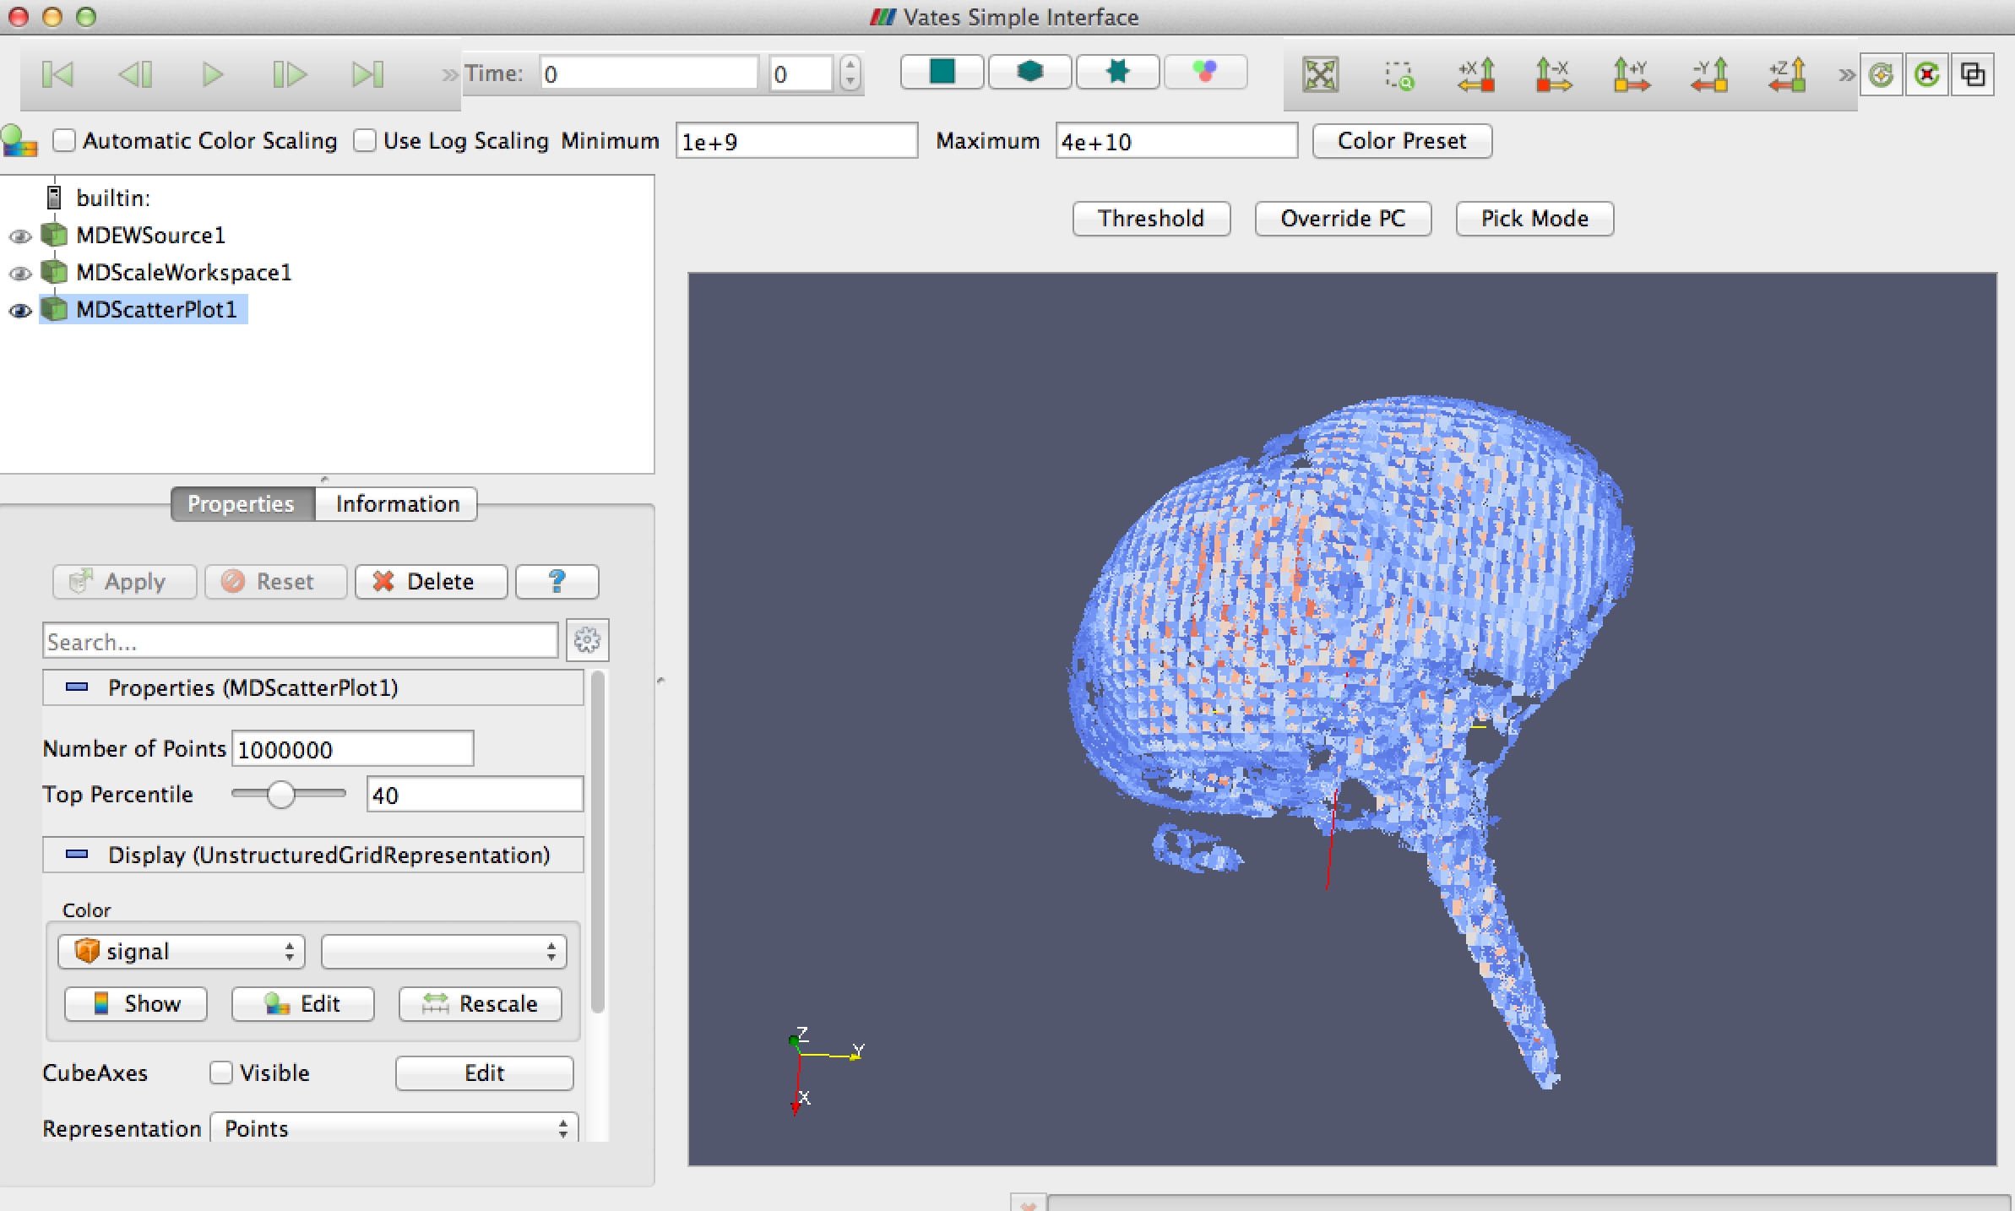
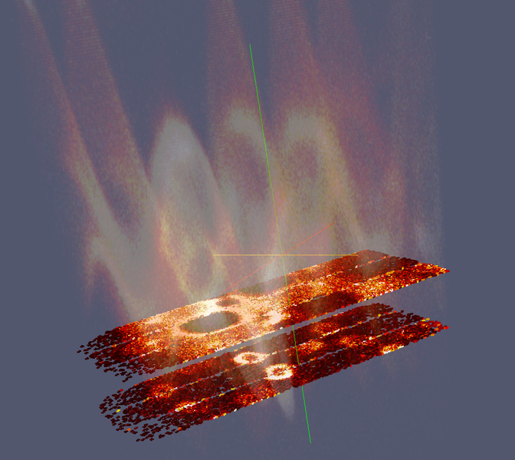
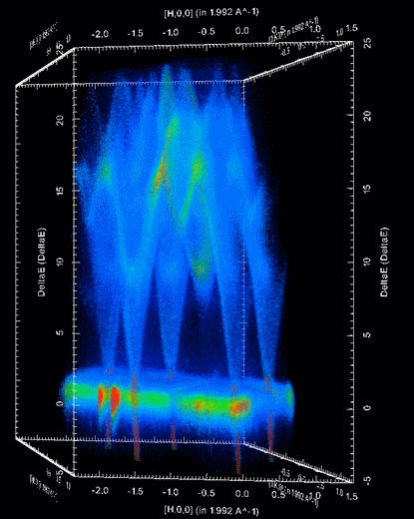

Document Control
This document is under document control. All members of the distribution list will receive updated copies whenever alterations are made. All other copies are uncontrolled.

Contributors
Name | Role | Company
Nicholas Draper | Author | Tessella

Document Approval
Name | Role | Company

Distribution
Name | Role | Company
Project Management Board Members | Recipient | Mantid Partnership
Mantid Project Repository | Filing | Mantid Partnership

Revision History
Author | Issue | Date | Description
Nicholas Draper | V1.R1.M0 | 06-June-2018 | 1st version written

References
Document | Ref | Date | Details and Version
Project Specification | [PS] |  | https://github.com/mantidproject/documents/blob/master/Project%20Management/ProjectSpecification.doc?raw=true
Stakeholder Plan | [SP] |  | https://github.com/mantidproject/documents/blob/master/Project%20Management/StakeholderPlan.doc?raw=true
Risk Register | [RR] |  | https://github.com/mantidproject/documents/blob/master/Project%20Management/RiskRegister.xls

Table of Contents
1 Introduction 3
2 Project Documentation 4
3 Project Status 4
4 User/Developer meeting 5
5 Areas for further collaboration 5
6 Usage of Mantid in various Environments 6
7 Future Release Dates 9
8 Appendix A: Metrics 10

Introduction

Purpose of this Document
This report details the current state of the Mantid project. The project management board will use this report as an item for discussion at the meeting.

Scope of this Document
The scope of this document is limited to the Mantid project, both for progress up to the meeting of the Project management board, and plans for the future.

Project Documentation
The project documentation is available through the links below. The documents have not been changed since the last PMB meeting.

Stakeholder Plan:
https://github.com/mantidproject/documents/blob/master/Project-Management/Stakeholder%20Map.doc?raw=true
Reviewed, No changes this time.

Risk Register:
https://github.com/mantidproject/documents/raw/master/Project-Management/RiskRegister.xls
Reviewed, No changes this time.

Project Status

Development Progress
Since the last PM report we have released the following new version of Mantid:

- Release 3.13 – 25th July 2018
The releases were made on time according to plan.

The next release 3.14 is currently planned for the 17th of December, with the following release plan:
- Code Freeze: 23rd November
- Beta Test: 27th November - 11th December

The next release after this is currently planned for release on the 1st of April 2019, with the current release plan:
- Code freeze: 8th March
- Beta test: 13th - 26th March
This would only give 2 months of development time before the code freeze, rather that the more normal 3 months per release. Another option would be to move this release back by 2 months (1 month would only have the release period overlapping with the user & dev meetings). If we did this it would be worth moving release 3.13 back by one month as well, to even the duration of the releases.
Development for this release has been going well, we had a significant boost in developers at ISIS over the summer with summer students and overlap of the sandwich students, but this is effectively balanced out with the cost of bringing new students up to speed..

The project metrics in Appendix A.

User/Developer meeting

Picking a date
The two dates that have been discussed so far are:
Date | Positives | Negatives
Wb 1st of April | ISIS preference: within a shutdown | Last week of beam at the SNS  ILL reactor restart is scheduled for 1st April
Wb 8th of April |  | DMSC scientific and technical advisory panel  UK School Holidays

One suggestion was that we could hold it in the first week, but hold the Developer meeting first, followed by the user meeting to move the user meeting to the latter part of the week, which might better suit instrument scientists from the SNS.

Areas for further collaboration

Initial identification
The development leads held a meeting in August to identify the areas of requirement most likely to have common interest across multiple facilities to focus future collaborative developments on. This meeting was intended as a first step to short list areas for further consideration.
The full output is available here:
https://docs.google.com/spreadsheets/d/1bcJwfeoYNyXKMFE3TM9XH1fR0u9zOeHhuuNCVH1Vq-E/edit?usp=sharing
However I’ll highlight here the areas of most interest, starting with two areas we are already developing collaboratively.
- Mantid 4.0 and the new workbench
- Developing mslice as a common slicing interface

Beyond those the following areas had the most consistent interest across at least 3 of the 4 facilities
- Closer integration with McStas / McVINE for multiple scattering etc.
- Improvements to defining ROI (lines, boxes, sectors, arcs, annuli) in instrument view and 2D plots
- Extract plots vs counts vs pixel/q/azimuthal angle
- integrated count/intensity
- Mulitiplots of instrument view views and colour fill plots
- With common colour scaling
- Absorption corrections for non trivial shapes (pressure cells, hollow cans), pre defined and reused by name (e.g. the “Yellow Cryostat”)
- Quick/semiautomatic fitting of diffraction peaks in selected 2theta/Q region for multiple diffractograms, giving e.g. intensity vs temperature or magnetic field.

Looking further into the list there were some that will need further investigation into the benefits vs costs and the relative desires of the instrument scientists and facility management:
- Developing a shared workflow and or UI for Engineering
- Adopting a common autoreduction framework

Next steps
Now people have returned after summer holidays I’ll start to arrange meetings involving developers and instrument scientists for these items and dig into the cost / benefit and interest as well as ensuring that all partners have a common view of what we are trying to achieve in that area. Areas with a clear benefit, and reasonable cost in terms of resources, I suggest we plan to implement and just report to the PMB. Areas that are more controversial will be brought before the PMB for discussion.

Usage of Mantid in various Environments
We currently fully support the following environments:
- RHEL 7 64bit
- Windows 7+ 64 bit
- Ubuntu 14.04 64 bit
- Ubuntu 16.04 64 bit
- OS X 10.10+
Limited Support:
- Fedora 20
- Ubuntu 16.04 64 bit

Current Usage:
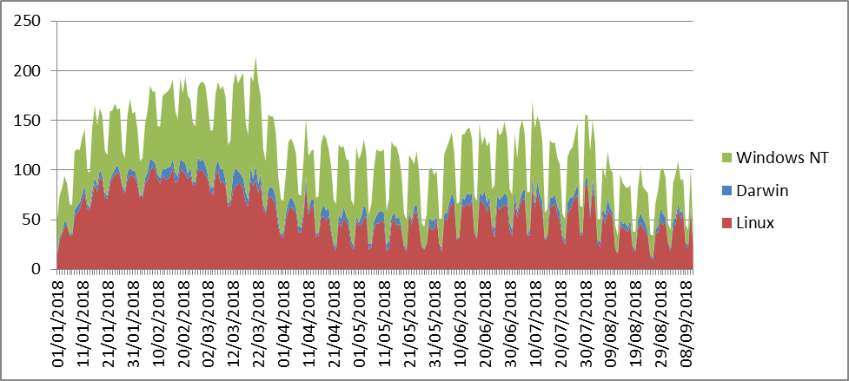

We average around 125 to 175 unique users per weekday, and around 50 – 100/day on weekends. Interestingly our highest usage was during January and February when less facilities were running, possibly scientists were taking the opportunity to analyse data? The drop in August is likely to be due to summer holidays.
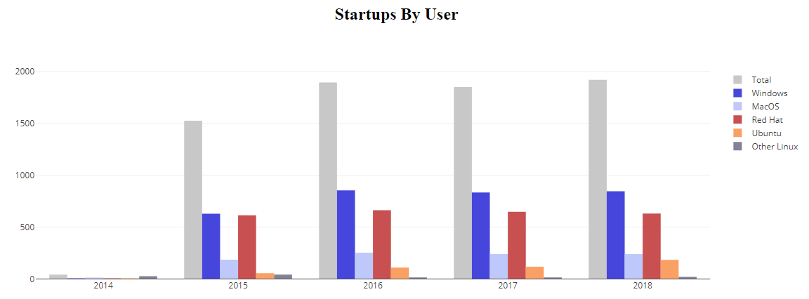
This graph shows the unique user count per year, the 2018 numbers are not for the partial year, I would expect them to be significantly exceed previous years by the year end.

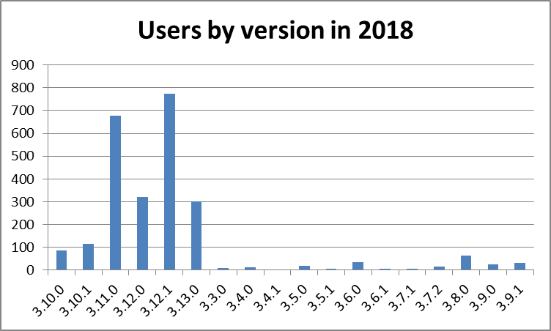
This is a view of the number of users that have used differenct versions of Mantid so far in 2018, Version 3.11.0 and 3.12.1 were the most current versions for a quarter of the year each, so it is normal for them to have such a high user count, the v3.13 has also been adopted well, and the user count is growing despite the slower adoption you might expect over August..
We have a significant tail of old versions, this is not a problem per se as long of the users of those versions do not need active support. Given the approach of visiting scientists leaving with a locally installed version then this is to be expected as they are unlikely to upgrade from the version that works for them.

Error Reporting
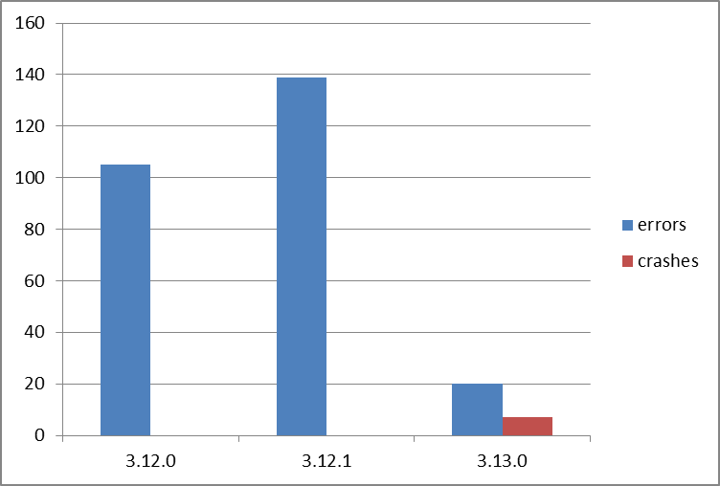
This graph shows both the raw numbers or errors and crashes sent through error reporting for each version. For the sake of this graph they are defined as:
- Errors – Problems that caused the ast chance error dialog within Mantidplot to appear.
- Crashes – Problems where Mantidplot exited impropoerly, this can include situations where it is terminated because it has hung.
Crash reporting was only introduced in release 3.13.0, so these occaisions went unreported in previous versions.

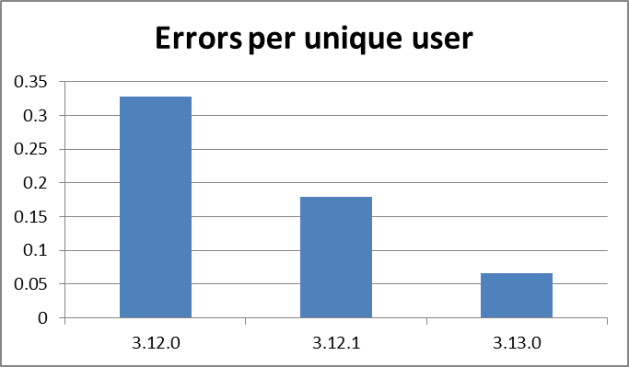
The graph also includes an attempt to normalise the number of errors by the amount that the release has been used. In this case it has been normalised by the number of unique users for that. This is an imperfect normalisation approach as the number of unique users does not rise linearly with usage, but gives a better insight into the stability of a release than the raw numbers alone.

Future Release Dates
Proposed dates:
- v3.15 1st April 2019
- v3.16 5th August 2019

Appendix A: Metrics

Project Metrics
The code metrics are independently generated and displayed here
http://www.openhub.net/p/Mantid/analyses/latest/languages_summary

Total Lines : | 2,345,034 |  | Code Lines : | 1,681,673 |  | Percent Code Lines : | 71.7%
Number of Languages : | 17 |  | Total Comment Lines : | 359,544 |  | Percent Comment Lines : | 15.3%
 |  |  | Total Blank Lines : | 303,817 |  | Percent Blank Lines : | 13.0%

Code, Comments and Blank Lines
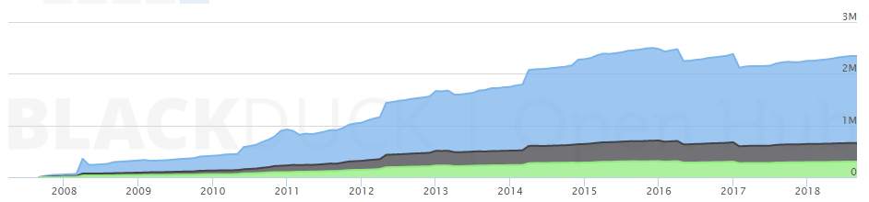
Code
Comments
Blanks

In a Nutshell, Mantid...
- has had 93,354 commits made by 154 contributors representing 1,681,673 lines of code
- is mostly written in C++ with an average number of source code comments
- has a well established, mature codebase maintained by a very large development team with stable Y-O-Y commits
- took an estimated 481 years of effort (COCOMO model) starting with its first commit in April, 2007

